📊 Lesson Plan: Data Visualization with Matplotlib

🎯 Goal
Learn the basics of Matplotlib and visualize business data using line, bar, histogram charts.

1. Introduction
- Matplotlib = the “engine” of Python data visualization.
- Used for quick plots and customized professional graphs.
- Works well with pandas DataFrames.

2. Line Graph: 💳 Sales by Payment Method Over Time

Code
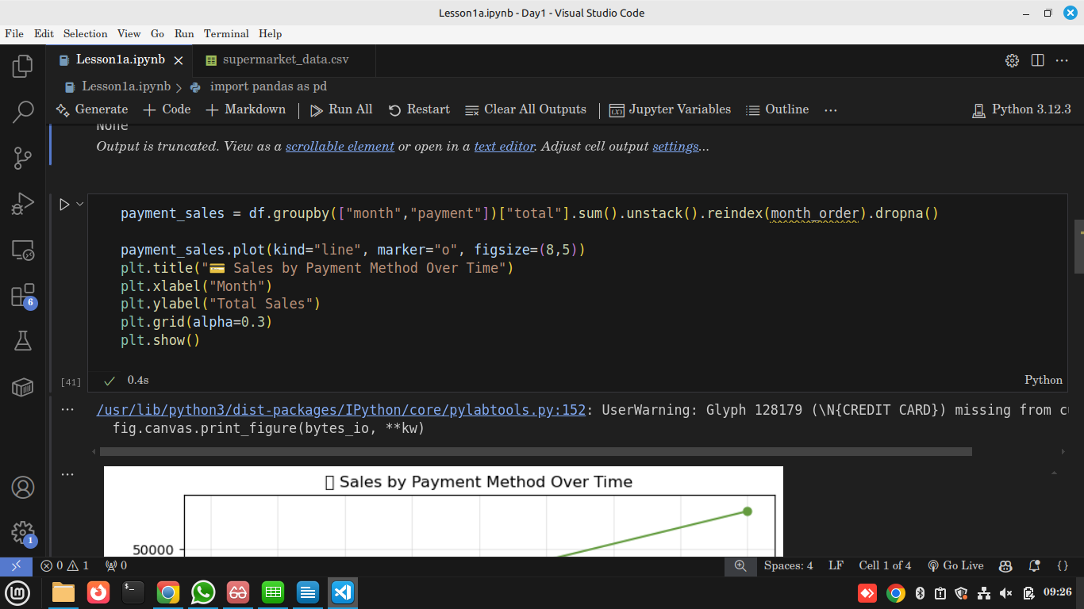

Output
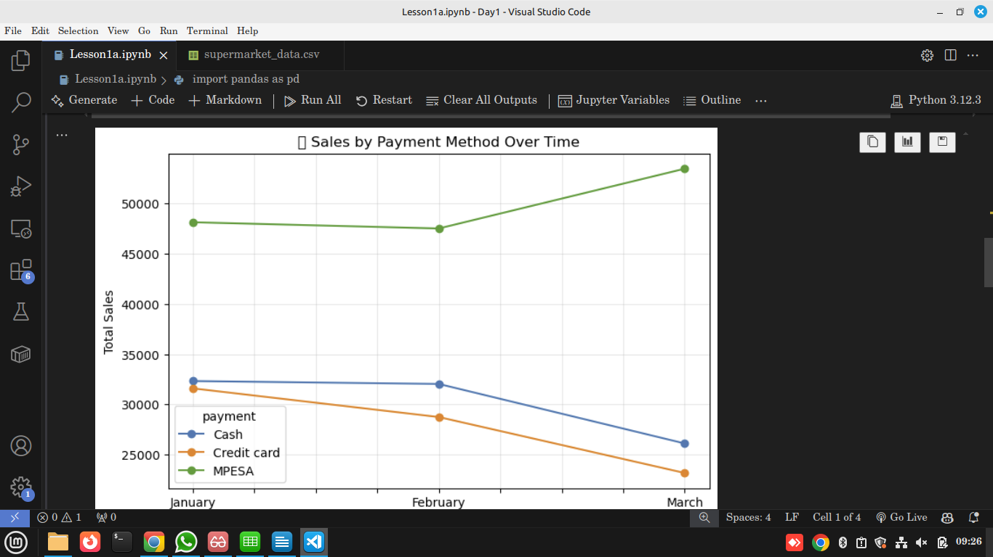

Explanation
- Line charts show trends over time.
- Here, we compare Cash, MPESA, Credit Card sales monthly.
- Helps businesses see:
  - Which method is most popular.
  - Seasonal changes in payment preferences.

3. Bar Chart: 🏙️ Total Sales by City
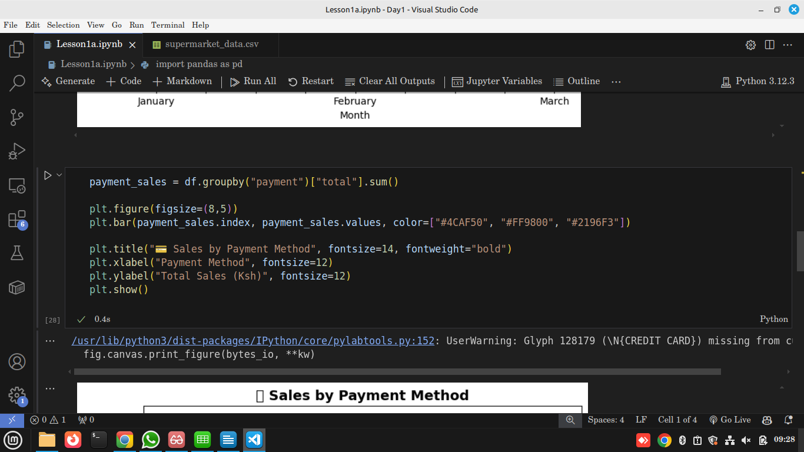

Output
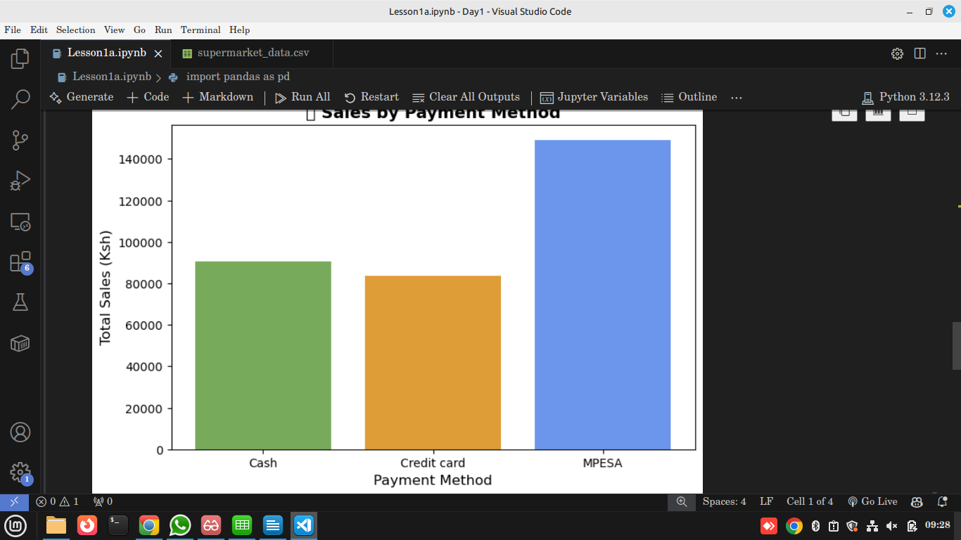

Explanation
- Bar charts are best for comparing categories.
- Shows which city brings in the highest sales (Nairobi vs Nakuru vs Kisumu).
- Business can decide where to open new branches or run promotions.

4. Histogram: 👩 Gender Distribution of Purchases

Code
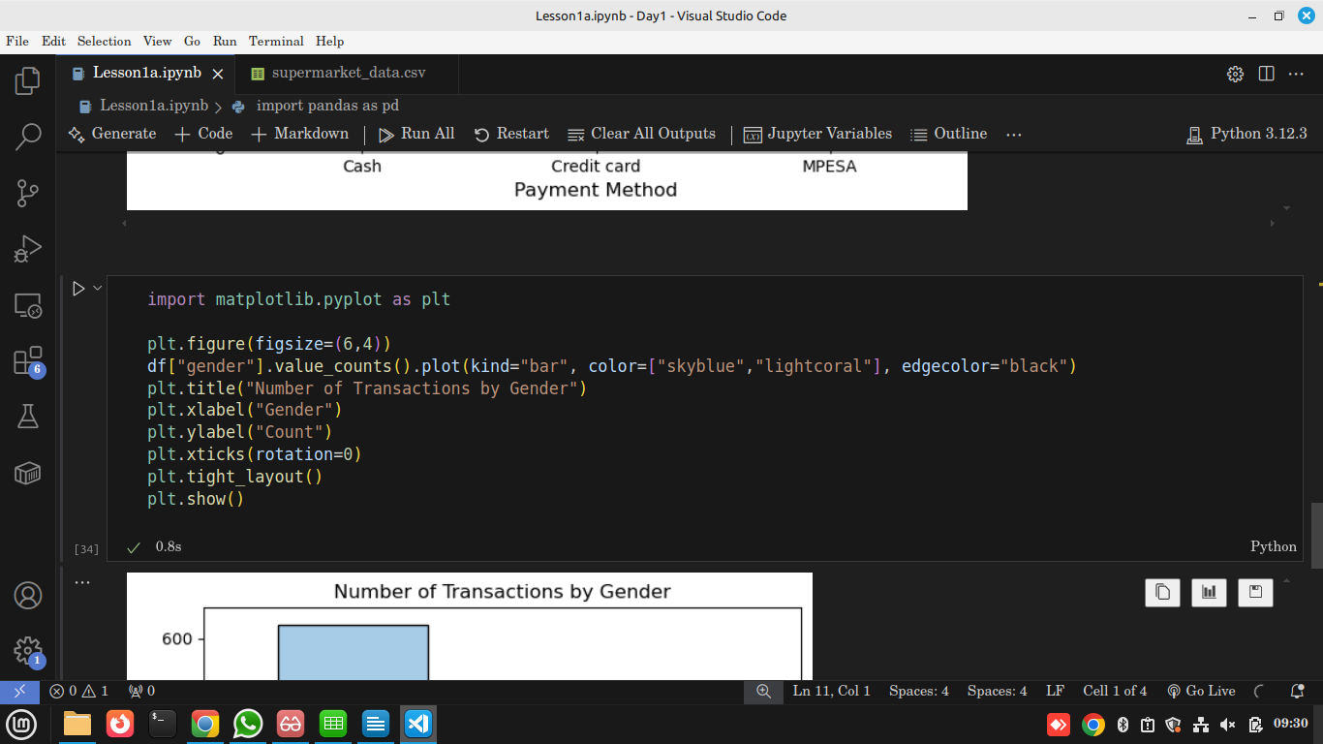

Output
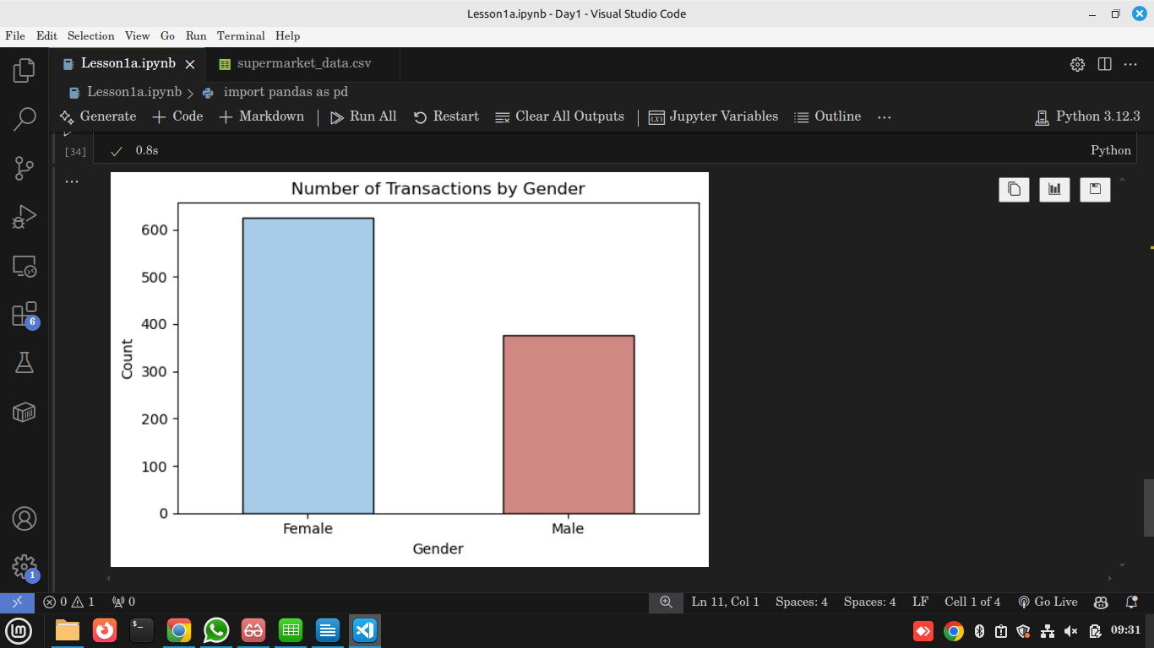

Explanation
- Histogram shows distribution of data.
- In this dataset: more purchases by female vs male customers.
- Helps in targeted marketing (e.g., female-focused products).

5. Reflection & Q/A (10 min)
- Line chart → Time trends.
- Bar chart → Category comparisons.
- Histogram → Distribution of values.
- Students discuss: Which chart would you use for product sales? For customer demographics?

